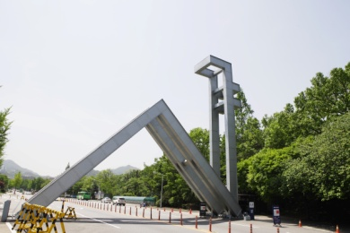
SNU GLOBAL
SCHOLARSHIPS

The College of Engineering, Seoul National University is proud to announce a call for outstanding graduate applicants in Engineering to pursue their dreams at one of the most prestigious university (4th in QS Asian University Rankings 2012).

Date & Time: June 11, 2012 15:00—16:30
ㅁ Venue: 工学院1号楼212会议室（北大东门外力学大院内新楼）
ㅁ Scholarship Award Guidelines and Eligibility Criteria
SNU will provide scholarships to 240 newly admitted students in undergraduate (80 students) and graduate (160 students) programs. The scholarship covers tuition & fees, living expenses, dormitory fees and return airfare.
*Applicants are accepted for all branches of Engineering such as
Architecture, Chemical & Biological Eng., Civl & Environmental Eng., Electrical Eng., & Computer Science, Energy Systems Eng., Industrial Eng., & Naval Architecture, Mechanical & Aerospace Eng., Technology Management Ecohomics & Policy, Urban Design, and Bioengineering
ㅁ SNU supports scholarship recipients’ Korean language training and mentoring.
ㅁ Application Opening: June/December 2012
ㅁ Session 15:00 Introduction of Seoul National University & Scholarship
15:20 Introduction of College of Engineering
16:00 Q&A
ㅁ Presenter : Prof. Rhee, Shin Hyung
(Dept. of Naval Architecture & Ocean Eng., Seoul National University)
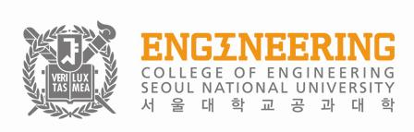
Presented by

