以色列理工大学暑期学校招募中国优秀学生
色列理工大学暑期学校即将于2013年7月31日至8月30日在海法举办。来自中国的优秀学生将获得由以色列政府资助的奖学金，此笔奖学金可以用来支付项目学费、留学生宿舍住宿费、每周5日的学校食堂午餐和每月$250的津贴。
附件为项目宣传册，具体课程内容详见以下及宣传册。请感兴趣的同学直接与对方（Tel. +972-4-8293325, Email: summer@int.technion.ac.il）联系。

Technion Summer School - Scholarship for Students from China
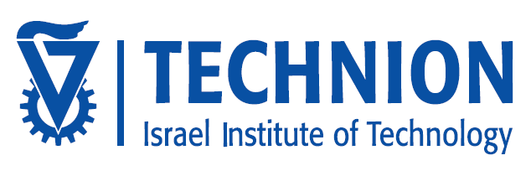
Technion Summer School will take place at Technion campus in Haifa between July 31 - August 30 2013.
Under a unique Israeli Government Sponsorship, excellent students from China will receive a scholarship covering full tuition costs for the program, including housing in Technion’s international village dormitories, daily lunch at a Technion cafeteria (5 days a week) and a monthly allowance of $250.
Attached please find the summer course brochure. Courses will be offered in fields of Electrical & Computer Engineering, Mechanical Engineering, Aerospace Engineerinng and Mathematics and are for Senior Undergraduate and Graduate students. Courses include:
- Image Processing and Analysis (Electrical Engineering)
- Introduction to Machine Learning (Electrical Engineering)
- Non-Negtaive Matrices - Theory and Applications (Mathematics)
- Distributed Space Systems (Aerospace Engineering)
- Principles of Guidance and Homing (Aerospace Engineering)
- Theoretical Tribology (Mechanical Engineering)
- History of the Israel and the Middle East (History)
Students will reside on campus and participate in industry visits and trips to Israel’s tourist attractions as well as leading companies, start-ups and investment companies to explore Israel's unique entrepreneurial economy. On campus, students get to meet Technion faculty, visit laboratories, and engage with lunchtime speakers providing in-depth exposure to Israeli and Middle Eastern culture and history.
For additional information and application forms please click here or contact summer@int.technion.ac.il

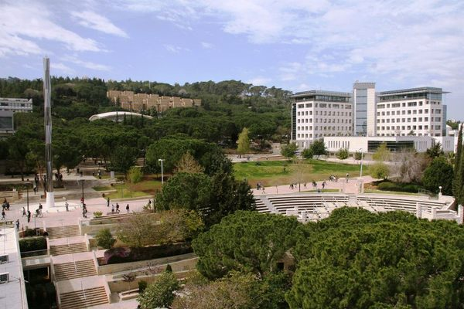
Technion - Center of Campus

